**Excel Assignment - 7**

1. Using Insert Function, give examples of any function available in the different dropdowns present in the function library. For example AutoSum, Recently Used, Text, Date & Time, etc.

Answer:

In Insert function, I am giving example of Auto sum:

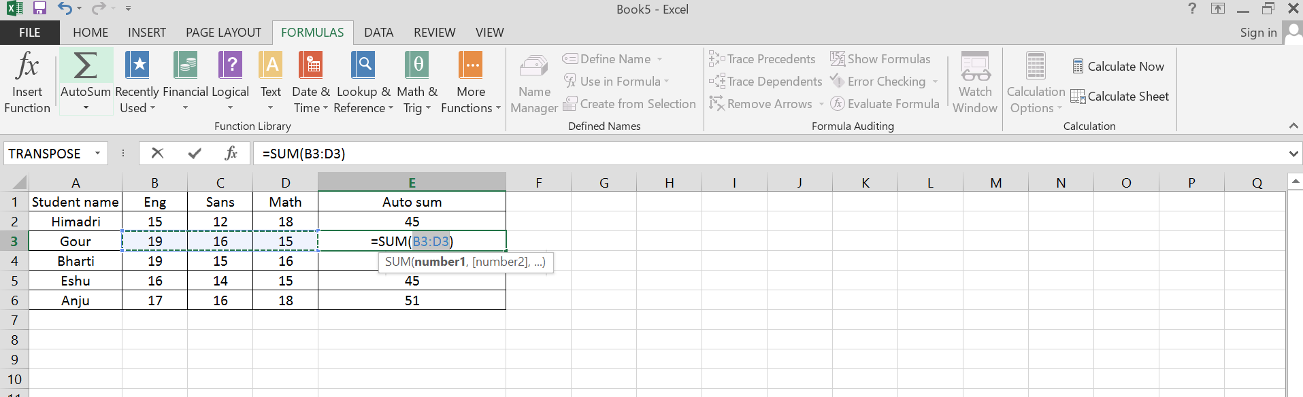

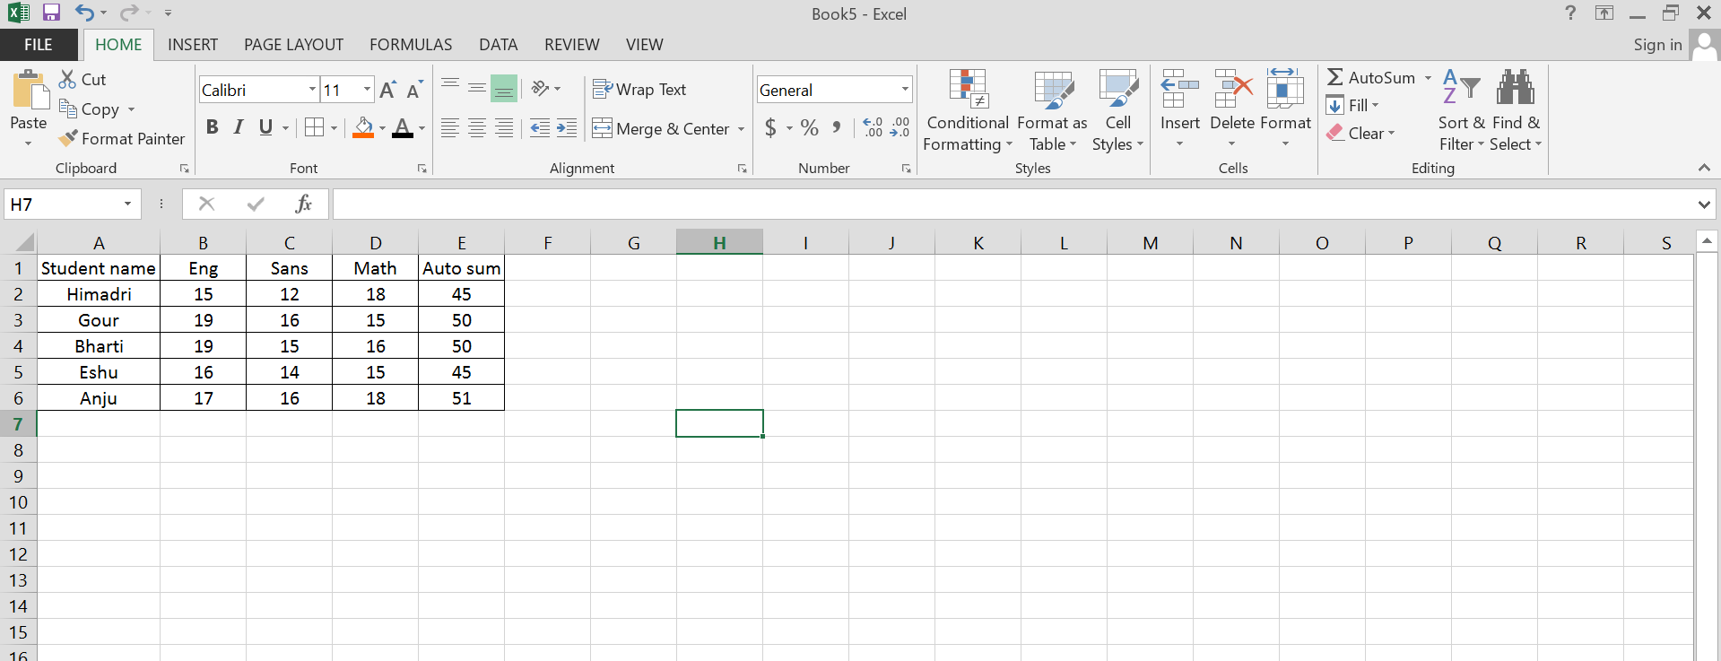

1. What are the different ways you can select columns and rows?

Answer:

* Select the letter at the top to select the entire column. Or click on any cell in the column and then press Ctrl + Space.
* Select the row number to select the entire row.
* To select non-adjacent rows or columns, hold Ctrl and select the row or column numbers.

1. What is AutoFit and why do we use it?

Answer: AutoFit is a feature in Excel that let us easily change the size of one or multiple columns or rows on a spreadsheet. It helps us to make sure that all the data in every cell group is clearly visible.

1. How can you insert new rows and columns into the existing table?

Answer:

* Click where you want in your table to add a row or column and then click the Layout tab (this is the tab next to the Table Design tab on the ribbon).
* To add rows, click Insert Above or Insert Below and to add columns, click Insert Left or Insert Right.

1. How do you hide and unhide columns in excel?

Answer:

Step 1: On the Home tab - Cells group - click Format.

Step 2: Go to Visibility

Step 3: Click Hide & Unhide

Step 4: Then click Unhide Rows or Unhide Columns.

1. Create an appropriate table within the worksheet and use different functions available in the AutoSum command.

Answer:

